Name:_____________________
Unit 5 Test Review
Answer all questions to the best of your ability, using the lessons and notes from class. It is suggested that you print out this review so you can use it to help you get an A+ on your test! The review session will be held Thursday 12/18/14 at 1pm.
*Turn into the Unit 3 Extra Credit Dropbox BEFORE Thursday 12/18/14 at 1pm for 3 points extra credit!
*Turn into the Unit 3 Extra Credit Dopbox AFTER Thursday 12/18/14 at 1pm for 1 point extra Credit!!

- Earth’s Atmosphere is made up of AIR, which is comprised of several gases. Match the piece of the pie chart below to the gas that makes up that %.
(Your options are Argon, Carbon Dioxide, Oxygen, and Nitrogen)
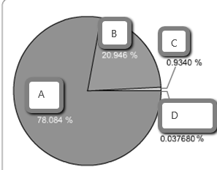
A.___________________
B. ___________________
C. ___________________
D. ___________________

- Atmospheric Layers: Please label the layers of the atmosphere on the picture below:
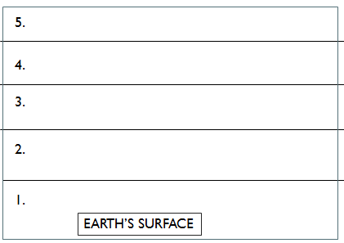
- Draw a star in the atmospheric layer above which contains the OZONE LAYER!

- Why do we care that volcanic activity was more common in the past than it is today?
  - Volcanic activity and gases from volcanoes shaped the environment.
  - Volcanoes are ancient and wise.
  - Scientists think that volcanoes cause rain to happen
  - Volcanoes do not happen today and are fascinating to study.

- Match the vocab term to the description below:

  - Absorbed i. Radiation from the sun is most concentrated here.
  - Reflected ii. When sunlight hits dark objects, it is ___________.
  - North and South Poles iii. Sunlight is least concentrated here.
  - The Coriolis Effect iv. Winds move from the sea to the land during the day
  - Sea Breeze v. When sunlight hits light objects such as clouds and snow, it is ___________.
  - Land Breeze vi. Earth’s rotation causes water/wind to move to the right (in the North Hem).
  - The Equator vii. Wind moves from the land to the sea during the night.

- Circle which substance heats up and cools down faster in each of the below pairs:

  - BLACK T-SHIRT or WHITE T-SHIRT
  - WATER or LAND
  - BLACK ASPHALT or GREEN GRASS
  - ICEBURG or OCEAN

- What does a barometer measure?

- 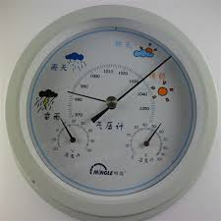The barometer to the left shows high pressure (see how the needle is to the right)? What kind of weather conditions would you expect to see with this barometric reading?

- Let’s pretend that the barometer above started changing and now points to LOW PRESSURE. What kind of weather conditions would you now expect to see?

- Wind moves from...
  - Low pressure to high pressure
  - High pressure to low pressure
  - Medium pressure to medium pressure
  - There is no such thing as wind.

- 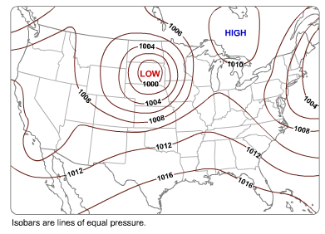
In the picture above, what are the lines called? What do they show?

- In the picture below, air rises at the equator where it is hot and sinks at the poles where it is cold. What is the movement of rising hot air and sinking cold air called?

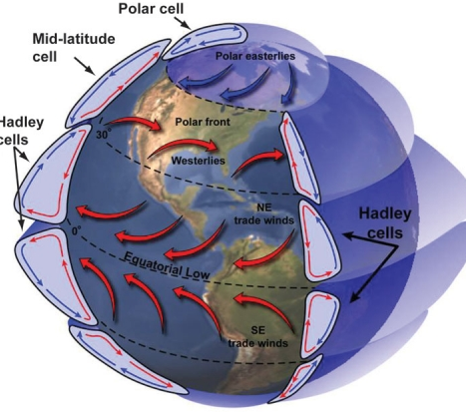
- List three global wind patterns shown in the picture above:

- What causes global wind patterns to happen?

- Bonus Question: Imagine that all the ice caps of the world melt due to warmer global temperatures. Less ice covers the world and more oceans now cover the world. Use the words REFLECTS, ABSORBS, RADIATION, and HEAT to describe how this could lead to an INCREASE in the earth’s temperature.
(Just try your best on this one. If you are stuck, don’t worry, we’ll go over it in class).

