Unit 4 Test Review
Answer all questions to the best of your ability, using the lessons and notes from class. It is suggested that you print out this review so you can use it to help you get an A+ on your test! The review session will be held Tuesday 11/20/14 at 1pm.
*Turn into the Unit 3 Extra Credit Dropbox BEFORE Tuesday 11/20/14 at 1pm for 3 points extra credit!
*Turn into the Unit 3 Extra Credit Dopbox AFTER Tuesday 11/20/14 at 1pm for 1 point extra Credit!!

- Fill in the Blanks: At certain times throughout Earth’s History Organisms have disappeared from Geologic Records due to ________ of mass ___________.
- Why do geologists study the relationship among rock layers?
- Which of the following would a geologist use to interpret the geologic history of an area?
  - Vegetation
  - Decomposed human remains
  - Soil sample
  - Rock layers
- Define Trace Fossils:
  - What would a trace fossil of a dinosaur footprint tell us?
- If a geologist found evidence of a trilobite fossil as well as thick walled clam Shells what would he surmise about the past environment/history of that region?
- Think back to when we talked about Microfosiils. The best preservation of a fossil includes:
  - Rapid burial and hard body parts
  - Slow burial and hard body parts
  - Rapid burial and soft body parts
  - Slow burial and soft body parts
- Geologic Time is separated into eras and periods. What event is used?
  - Volcanic eruptions
  - Movement of tectonic plates
  - Appearance and disappearance of groups of organisms
  - A volcanic eruption

- True or False: Volcanic activity was more common in the past than it is today.
  - True
  - False
- Define Relative Dating:
- James Hutton came up with the Theory of Uniformitarianism while observing the geologic processes at work on his farm in Scotland in the late 1700’s. The Theory of Uniformitarianism States:
- Finding a fossil of a land dwelling dinosaur on the coast of South America and the coast of Africa tells you
  - The two continents were once joined
  - That organism was able to swim across the water
  - That organism hitched a ride regularly from a flying animal
  - The dinosaur periodically grew wings and flew across the water
- Define Absolute Dating:
- Using the diagram below which rock layer is the oldest? Why?

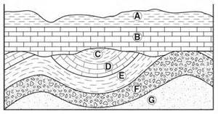
- In complete sentences, When is absolute dating more useful than relative dating?

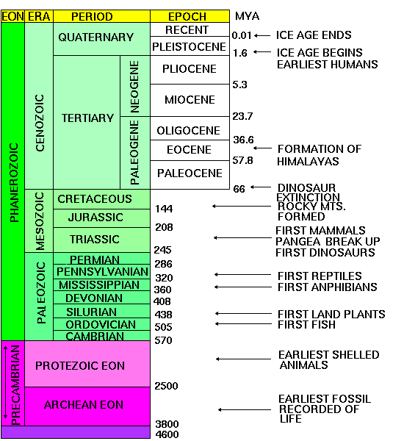

- Using the Geologic Time Scale above answer the following questions:
  - Why are there more fossils found in the Precambrian eon than the Phanerozoic eon?
  - Does the Precambrian eon or the Phanerozoic eon represent the largest number of years?
  - During which Period did Pangea break up?
Using your Unit 4 Vocab Sheet to help you place the words in the Word Bank next to their definition.
Word Bank: Abiotic Coprolite Evolution Extinction Ecosystem Geologic Time Scale Half Life Iridium Natural Selection Outcrop Radiometric dating Protons Nucleus Neutron Isotopes

__________-part of a rock formation that appears at the surface
___________-fossilized excrement of a vertebrate
____________-a community or group of organisms living and interacting with each other and their environment
_____________-the process whereby groups of organisms evolve, or come to differ from their ancestors, through various means, including natural selection and genetic factors
_____________-the disappearance of all members of a species so that the species no longer occurs anywhere
_________- the trace or remains of an organism preserved in rock
____________-the time needed for half of a sample of radioactive material to decay
______________-a rare, hard, and heavy metallic element
__________-part of a rock formation that appears at the surface
_____________________-the process by which individuals tend to be eliminated from a population so that they leave few descendants to pass on their characteristics
_________________-also isotopic dating; method to calculate age of a geologic material by measuring its content of a short-lived radioactive element or its content of a long-lived radioactive element and that element´s decay product
_______________________-chronological sequence of geologic events used as a measure of the duration or age of any part of geologic time
_______________-the idea that processes at work today on earth are the same processes that worked on earth in the past; accounts for geologic features and geologic changes
___________-a positively charged particle found in the nuclei of atoms
_________-not biotic; that is, not of, relating to, or caused by living organisms
__________-part of a rock formation that appears at the surface__________-a neutral particle with approximately the same mass as a proton, found in nuclei of atoms with protons
_________-atoms of the same element that differ in the number of neutrons in the nucleus

