Name:_______________________

Earth Science: Unit 2 Review

Answer all questions to the best of your ability, using the lessons and notes from class. Complete sentences are not necessary for this assignment. It is suggested that you print out this review so you can use it to help you get an A+ on your test!

- Turn into the Unit 2 Extra Credit Dropbox BEFORE Thursday, 10/16 at 1PM for 3 points Extra Credit!
- Turn into the Unit 2 Extra Credit Dropbox AFTER Thursday, 10/16 at 1PM for 1 points Extra Credit!

- Alfred Wegener had a radical idea called ________________ drift. What 2 pieces of evidence did he use to hypothesize that the continents used to fit together?

  - ___________________________________

  - ___________________________________

- What are the three types of convergent boundaries? Make sure they match the descriptions listed!
  - ________________________________ - Trenches (subduction), mountain ranges, and volcanoes are here.
  - ________________________________ - Huge mountain ranges and earthquakes are here, no trenches present.
  - ________________________________ - Island Arcs like Japan form here.

- The Alps are a huge mountain range in Europe. Which of the three convergent boundaries listed above is responsible for forming the Alps?

Please use the following picture to answer questions 2-5:

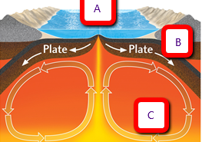

- In the picture above, A shows a…
  - Convergent Plate Boundary Zone
  - Divergent Plate Boundary Zone
  - Transform Plate Boundary Zone

- At A, new seafloor is being created. This is called an ocean ridge and also known as an oceanic _______________ center.

- What is the layer of the earth shown at C?
  - Inner Core
  - Outer Core
  - Mantle
  - Crust

- Which letter shows a trench? Trenches are at ____________-______________ convergent boundaries and are also known as _________________ zones

- A convection cell is shown at which letter in the picture above? _________________

- In a convection cell, _________&____________________ fluids rise and ____________&__________________ fluids sink.

WORD BANK: Cold, Hot, Less Dense, More Dense

- What kind of evidence is used to show seafloor spreading?
  - Fossil record
  - Earthquake locations around the world
  - Paleomagnetic record of magnetic field reversals
  - Rainbows and unicorns

Use the following picture for questions 11-13:
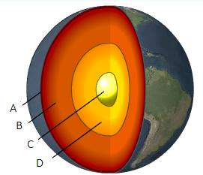
- Which layer of the earth is the densest?_______________

- Which layer of the earth is liquid?__________________

VOLCANOES:

- Material that forms volcanoes comes from which layer of the earth? ______________________

- Do hotspots happen at plate boundaries or at random spots on plates?

- Circle all that are possible results of volcanic eruptions:
  - Acid rain
  - Destruction of homes
  - Island chain formation
  - Seismic waves
  - Spewing of lava
  - Subduction
  - Ash accumulation
  - Blocked sunlight
  - Lake formation
  - Superheroes saving the day

EARTHQUAKES:

- Seismic waves originate at _____________________. What are the first two types of seismic waves that arrive?

  - _____________________________ - Can travel through a solid and liquid

  - _____________________________ - Can only travel through solids

- Of the seismic waves, which one comes first?
  - S Waves
  - P Waves
  - Nobody knows!

- A seismometer measures and records what?
  - Radiation
  - Seismic waves
  - Ability of waves to travel through a medium
  - Teacher’s moods

- Triangulation (shown below) is used to determine the location of what related to earthquakes?_______________
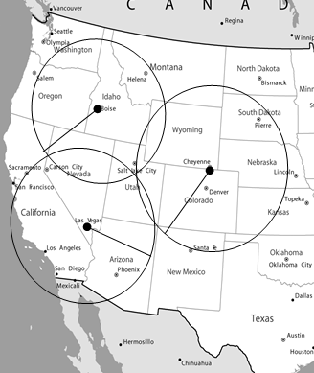

- How is the epicenter of an earthquake different from the focus?

