Unit 1, Semester 2 Test Review
Answer all questions to the best of your ability, using the lessons and notes from class. It is suggested that you print out this review so you can use it to help you get an A+ on your test! The review session will be held Tuesday 02/17/15 at 1pm.
*Turn into the Unit 3 Extra Credit Dropbox BEFORE Tuesday 02/17/2015 at 1pm for 3 points extra credit!
*Turn into the Unit 3 Extra Credit Dropbox AFTER Tuesday 02/17/2015 at 1pm for 1 point extra Credit!!

- Climatic regions are classified according to _________________ and ____________________.
- What is weather?
- What is climate?
- Circle the greenhouse gases below:
  - Carbon dioxide
  - Methane
  - Oxygen
  - Water Vapor
  - Nitrous Oxide
  - CFC’s
- Explain what the climate is like for the tropical region known as the Savanna.
- The Marine West Coast has what type of vegetation?
- Fill in the blank: Highland regions are colder than the surrounding regions because temperature ______________ with altitude.
- The cold current travelling along the west coast of California causes the climate to be __________ than expected.

  - Warmer
  - More extreme
  - Cooler
  - Sunnier
- The picture below shows the rings of a tree. The thick ring indicates a rainy season. You can also see a scar from a forest fire. The empty box is pointing to a very thin line indicating a small amount of growth. Why would the tree have little growth during that year?

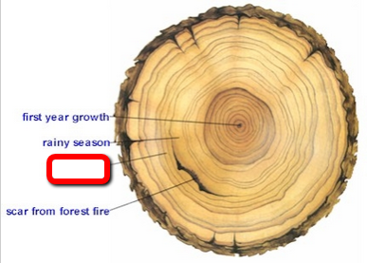

- A very cold period in Earth’s history resulted in an increase in __________________.
  - Tree growth
  - Glaciers
  - Precipitation
  - Sunny days
- What happens to Earth’s climate after a very large volcanic eruption?
- Fill in the missing blanks from the chart below:
 | El Nino | La Nina
What happens | Brings warm water to S. America
Upwelling (upward movement of cold water from the ocean depths) |  | Yes
Affects to aquatic life | No nutrients coming to the surface
Human impacts |  | Fish do well. Increase in number of fish.
How does it affect Michigan | Milder, less snow

- The surface temperature of Venus is higher than that of Mercury as a result of ______________________.
  - Venus being a larger planet
  - Mercury being farther from the sun
  - The greenhouse effect on Venus
  - Mercury not orbiting the sun
- How has the climate of the Mojave Desert impacted the vegetation that grows there? 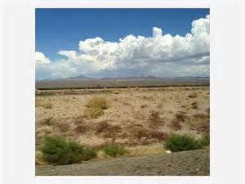

- What does the trend line below tell us about the temperature of the Earth as the amount of greenhouse gases increase?
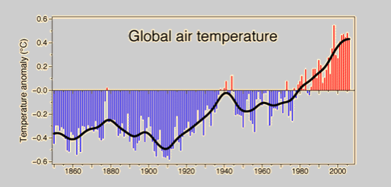

- How do the Great Lakes affect the weather of the cities around them?
- Contrast the climate of Michigan with the climate of Hawaii.

