Name:_______________________

Earth Science: Unit 1 Review

Answer all questions to the best of your ability, using the lessons and notes from class. Complete sentences are not necessary for this assignment. It is suggested that you print out this review so you can use it to help you get an A+ on your test!
- Turn into the Unit 1 Extra Credit Dropbox BEFORE Thursday, 9/18 at 1PM for 3 points Extra Credit!
- Turn into the Unit 1 Extra Credit Dropbox AFTER Thursday, 9/18 at 1PM for 1 points Extra Credit!

- Circle the letters of the topics earth scientists study:
  - Rocks
  - Space
  - Machines
  - Oceans
  - Minerals
  - Plants
  - Planetary Changes
  - Natural Disasters
  - Biology
  - Farming Methods

- Label the four main steps of the scientific method. Put a star next to the step that is the most important.
(Need help? Go to Unit 1 Lesson 3)

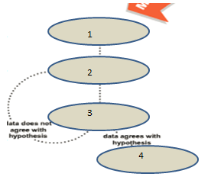

- A good hypothesis has which two words always included?
____________ and _____________

- Is the following sentence a good hypothesis? If it is not, explain why it is not and rewrite it correctly.

If I study and turn in my homework I will get a good grade.

- Write an example of a good hypothesis.

- According to the lessons and what we learned in class, which step of the scientific method is the most important?

- What is a good reason to study earth science?
  - So we can understand plants and how they reproduce.
  - To predict planetary changes and how our earth may change in the future.
  - To cure infectious diseases which affect many people living on the planet earth.
  - To take over the world with Pinkie and the Brain.

- How old do earth scientists estimate that the earth is?
  - 8,000 years old
  - 40 million years old
  - 4.5 billion years old
  - 490 billion years old

- How did scientists make the above estimation of the age of the earth? They used ___________________ dating.

- List the earth spheres we learned about in class and list at least two parts that make up each. The first one is done for you!

  - __Hydrosphere__ - Streams, lakes, rivers, oceans.
  - ______________
  - ______________
  - ______________
  - ______________
- Each of the following scenarios includes two spheres interacting. Write the two interacting spheres next to each example.

  - A heat wave causes crops to die and people go hungry=

  - Rain causes a stream to flood =

  - The ozone layer protects humans from sunburns and skin cancer=

  - Polar ice melts into the ocean =

  - Volcano erupts and emits ash that lowers the global temperature=

- Old dude scientists – match the scientist to their historical contribution to earth science:

  - William Smith

  - Kepler

  - Ptolomey

  - Copernicus

- The sun is in the center of the universe
- The earth is in the center of the solar system
- All planets go at their own elliptical orbit around the Sun
- Rock layers with the same fossils are the same age

- Define geocentric –

- Define heliocentric –

- Write: How did scientists’ knowledge of planetary motion change over time? Use the word observation, hypothesis, gathering data, and conclusion as well as the names Ptolomey, Copernicus, and Kepler to explain how our knowledge of planetary motion has changed over time.

- What does a topographic map show that a traditional map does not show?

- Circle: Contour lines connect places with (THE SAME/DIFFERENT) elevation.

- By looking at the contour lines on a topographic map, how can I tell if a slope is very steep or gentle?

Use the below topographic map to answer questions 19 -22.

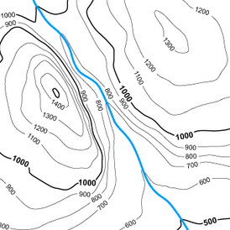

- What is the contour interval on this map?
  - 1 meter
  - 10 meters
  - 100 meters
  - 1000 meters

- Which direction does the river flow and how do you know?

- Where is the steepest slope on the map? How do you know?

- Match the topographic maps to their side view:

