Name: _________________
Earth Science Semester 1 Test Study Guide
Earth Science: Semester Test Review
Answer all questions to the best of your ability, using the lessons and notes from class. It is suggested that you print out this review so you can use it to help you get an A+ on your test! The review session will be held Tuesday 1/20/15 at 1pm.
*Turn into the Unit 7 Extra Credit Dropbox BEFORE Tuesday 1/20/15 at 1pm for 5 points extra credit!
*Turn into the Unit 7 Extra Credit Dopbox AFTER Tuesday 1/20/15at 1pm for 2 points extra Credit!!
- Define uniformitarianism in your own words:

- What is the theory of plate tectonics?

- What are the three types of plate boundaries? Describe the plate movement at each one.
  - ___________________
Plate Movement:
  - ____________________
Plate Movement:
  - ____________________
Plate Movement:
- The Pacific Ocean is shrinking. Which kind of plate boundary is likely involved?

- If an ocean is expanding, which kind of plate boundary would likely be present?

- What kind of natural disaster is often found at transform boundaries?

- There are two kinds of seismic waves that come from Earthquakes. Name them and state the relative speed in which they travel through the Earth.

- What do seismographs measure?
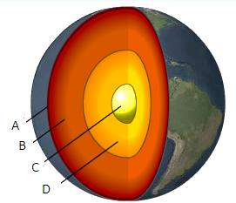
- Label the layers of the earth using the picture above.
  - __________________________
  - __________________________
  - __________________________
  - __________________________

- Convection cells drive plate tectonics. Which layer of the Earth does convection take place in?

- Describe convection. Draw a picture below and label it. (Be sure to use the terms more dense and less dense).

- How did Hawaii form? Are all the islands active volcanos?

- How would you test a mineral’s streak?

- Why is coal not a mineral?

- The mineral property _________________ is easily observed but can be unreliable for mineral identification.
- What are the three rock types?

- Rocks formed from a change due to heat and pressure are _________________ rocks.
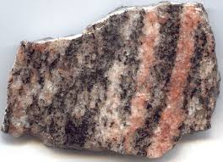
- The picture above shows a rock with __________
  - Appropriation
  - Foliation
  - Weathering
  - Communication

- Give an example for each word below:
  - Chemical Weathering
  - Mechanical Weathering

- In your own words, answer the following question. What is erosion?

- List the 5 layers of the Earth’s Atmosphere from bottom to top.

- In which layer is the ozone layer found?
- How does the ozone layer help humans?
- In which layer of the atmosphere do we live?
- What is the most abundant gas in the current atmosphere?

- How did volcanic outgassing affect the early atmosphere?

- How is heat energy transferred from a warm object to a cold object when there is direct contact?
CIRCLE: Conduction, Convection, or Radiation

- The following picture shows a pot of boiling water on a stove. Please place the words CONDUCTION, CONVECTION, and RADIATION on the picture where they belong.
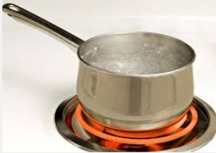
- Where on the Earth does the sun’s energy hit the surface at the most direct angle? This location receives the most concentrated energy from the Sun.

- What is the Coriolis Effect?
- What causes the Coriolis Effect?

- Describe land breeze and sea breeze.

- What is the difference between weather and climate?

- What weather instrument measures atmospheric pressure?
- Pressure Systems. What kind of weather would you expect to see with each pressure system?
  - High Pressure:

  - Low Pressure:

- Would you expect to have a hurricane during a high or low pressure day?
- In the picture below, what is the oldest layer and how do you know?
